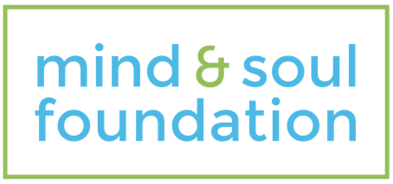

Sunday, XX XXXX, 20XX
Sunday Morning Service : 10:00

Time | Length | Topic
10:00 AM | 5 | Song: Blessed Be Your Name Beth Redman, Matt Redman
10:05 AM | 5 | Song: My Hope Is You Brad Avery, David Carr
10:10 AM | 5 | Welcome | Introduce topic  Senior Pastor/Minister
10:15 AM | 3 | Video - It's Not About the Nail  https://www.youtube.com/watch?v=-4EDhdAHrOg  [to emphasise the need to keep this topic light-hearted]
10:18 AM | 3 | Notices
10:21 AM | 2 | Kids to their Groups | Meet & Greet those sitting next to you
10:23 AM | 5 | Song: Desert Song Brooke Ligertwood
10:28 AM | 5 | Song: Man Of Sorrows Brooke Ligertwood, Matt Crocker
10:33 AM | 1 | Offering
10:34 AM | 20 | Interview with panel of professionals  Videos:  Black Dog' video to play during interview (first) - https://www.youtube.com/watch?v=XiCrniLQGYc  'Mind & Soul' video to play during interview (second) - https://vimeo.com/217624665 [can be downloaded]
10:54 AM | 4 | Song: Kingdom Phil Rose
10:58 AM | 10 | Interview with someone with a mental health problem
11:08 AM | 5 | Communion
11:13 AM | 5 | Song: You Never Let Go Beth Redman, Matt Redman
11:18 AM | 2 | Close | Benediction

